Park in the Sports Complex Garage 875 W. New York Street (visitor parking) – https://map.concept3d.com/?id=791#!m/7911269

Visitor parking is on first floor of the garage. Use the first entrance closest to Blake St.

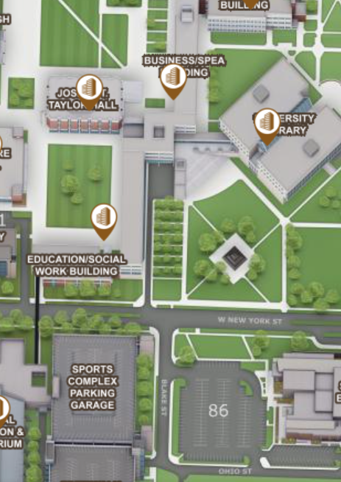
IUPUI Business/SPEA Entry #3
Sports Complex Parking Garage

Walk across New York Street and enter the Business/SPEA Building at Entry #3 (under the building’s breezeway) – https://map.concept3d.com/?id=791#!m/7910494

Take the elevator to the 4th Floor. Take a right off the elevator and classroom BS 4095 will be directly ahead.
---------------------------------------------------------------

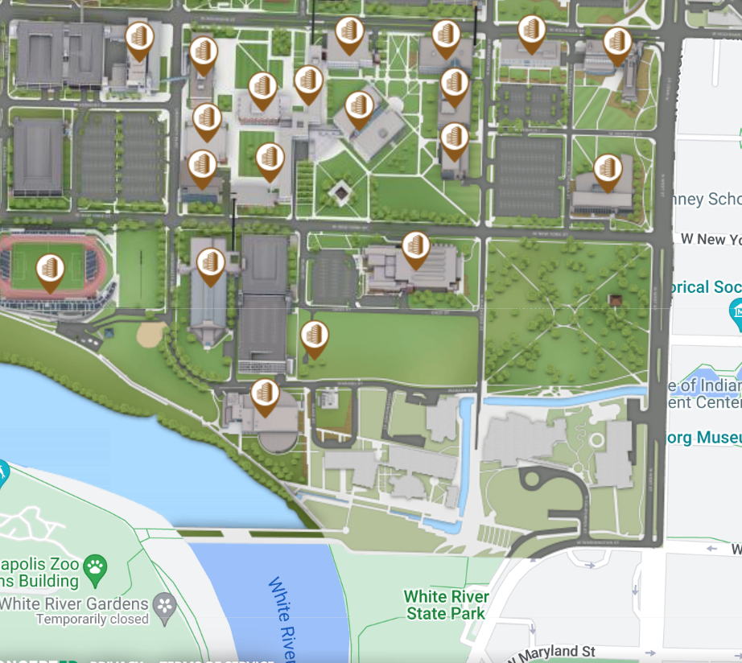
IUPUI Business/SPEA Building Entry #3
JW Marriott

